CREATE TABLE STUDENT_EXP7_CSA_46(ROLL_NO VARCHAR(10),NAME VARCHAR(20),PHYSICS VARCHAR(20),CHEMISTRY VARCHAR(20), MATHS VARCHAR(20));

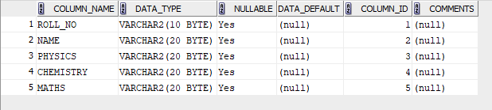

INSERT INTO STUDENT_EXP7_CSA_46 VALUES(1,'ADAM',20,20,33);

INSERT INTO STUDENT_EXP7_CSA_46 VALUES(2,'BOB',18,9,41);

INSERT INTO STUDENT_EXP7_CSA_46 VALUES(3,'BRIGHT',22,7,31);

INSERT INTO STUDENT_EXP7_CSA_46 VALUES(4,'DUKE',13,21,20);

INSERT INTO STUDENT_EXP7_CSA_46 VALUES(5,'ELVIN',14,22,23);

INSERT INTO STUDENT_EXP7_CSA_46 VALUES(6,'FLETCHER',2,10,48);

INSERT INTO STUDENT_EXP7_CSA_46 VALUES(7,'GEORGIA',22,12,22);

INSERT INTO STUDENT_EXP7_CSA_46 VALUES(8,'MARY',24,14,31);

INSERT INTO STUDENT_EXP7_CSA_46 VALUES(9,'TOM',19,15,24);

INSERT INTO STUDENT_EXP7_CSA_46 VALUES(10,'ZACK',8,20,36);

SELECT * FROM STUDENT_EXP7_CSA_46;

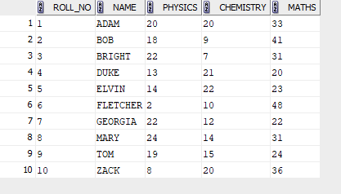

SELECT AVG(PHYSICS) FROM STUDENT_EXP7_CSA_46;



SELECT MAX(MATHS) AS HIGHEST_MARKS_MATHS FROM STUDENT_EXP7_CSA_46;



SELECT MIN(CHEMISTRY) AS LOWEST_MARKS_CHEMISTRY FROM STUDENT_EXP7_CSA_46;

